[](https://electrosome.com/wp-content/uploads/2013/05/paper-thin-battery-flex.jpg) **The Paper Battery**

A paper battery is an energy source which is more flexible and thin. This device is a combination of carbon nanotubes with cellulose based paper.  The paper battery can act in two ways. A battery  as well as a super capacitor. These non-toxic, flexible batteries  can be used as a power source to next generation electronic devices, medical devices, hybrid vehicles, etc.

**The Future Power Source**

Scientists have developed batteries of size slightly larger than a postal stamp that can produce energy that is enough to illuminate a small bulb. In future we can expect a stack of paper batteries that is able to power up a car. These are the power source to next generation electronic devices, medical devices, pace makers,  hybrid vehicles, etc.

**Manufacture**

One method is to grow  the nanotubes on a silicon substrate and then filling the gaps in the matrix with cellulose. When  the matrix is dried, the material can be removed  the substrate. Combining the sheets together  with the cellulose sides facing inwards, the battery structure is formed. The electrolyte is added to the structure.

[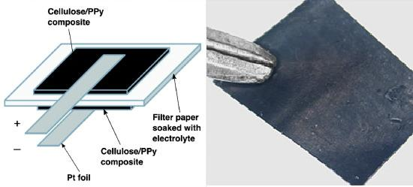](https://electrosome.com/wp-content/uploads/2013/05/organic-paper-battery1.jpg)

**Advantages**

The main advantage of the paper batteries is that it can be folded, cut or shaped for the required applications without any loss in its efficiency. If the battery is cut into half, the energy produced by them is halved. Stacking more than one paper batteries multiplies its power output. A sample of size of a postal stamp is able to produce about 2.5 volts of electricity. These batteries are also environment-friendly.  Presence of cellulose  and lack of toxic contents in paper batteries makes the device  environmentally friendly, compared to the traditional lithium ion batteries.